| PROJECT INFORMATION | | | |
| --- | --- | --- | --- |
| **Report Description:** | Timeline | | |
| **Professor:** | Prof. [Gady Agam](mailto:agam@iit.edu) | **Tools used/work done:** |  |
| **Report prepared by:** | [Noviya Balasubramanian](mailto:nbalasubramanian@hawk.iit.edu) |
| **HAWK ID:** | A20541236 |
| **Report no:** | 6 | **Report Date:** | 9/27/2024 |

**Topic: *Classification of Cognitive States Using EEG and Physiological Signals: Impasse, Aha!, Uncertainty***

Timeline:

1. First 6 Weeks: Literature Review, Data Access, Preprocessing, Problem Statement Definition
2. Week 7 (Oct 4): Data Preprocessing Completion, MARA Exploration in MATLAB
3. Week 8 (Oct 11): Feature Extraction and Classification, Initial Training
4. Week 9 (Oct 18): Classifier Selection and Initial Training
5. Week 10 (Oct 25): Classifier Optimization and Validation
6. Week 11 (Nov 1): Multimodal Analysis
7. Week 12 (Nov 8): Fusion or Comparison Analysis Scope
8. Week 13 (Nov 15): Final Testing
9. Week 14 (Nov 22): Model Evaluation
10. Week 15 (Nov 29): Report Preparation (Buffer)
11. Week 16 (Dec 6): Report Submission

[1] Kyriaki, Konstantina, Dimitrios Koukopoulos, and Christos A. Fidas. "A Comprehensive Survey of EEG Preprocessing Methods for Cognitive Load Assessment." IEEE Access (2024).

MARA is an automated and efficient classifier that utilizes a binary linear classifier to determine whether an IC is an artifact or a neuronal signal, thereby enabling researchers to retain or reject it. MARA has demonstrated a strong performance online and in various experimental contexts. It handles effectively different types of artifacts [63], particularly myogenic artifacts [3]. After feature selection, classification was performed using the K-Nearest Neighbors (KNN) and Support Vector Machine (SVM) algorithms. A remarkable classification accuracy of 98.79% was cited, significantly higher than the classification based on features from the time, frequency, or time-frequency domains.

This weeks work - Labeling the components, analyzing with MARA

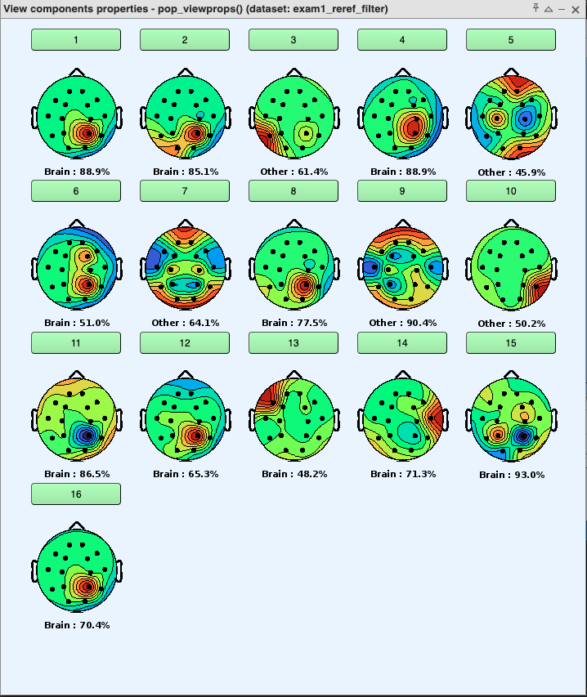

MARA - Multiple Artifact Rejection Algorithm:

(Please zoom in this image)

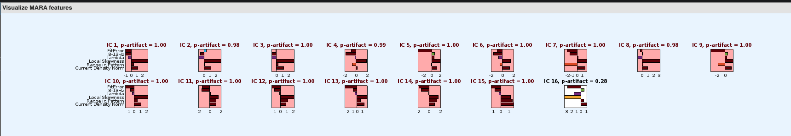

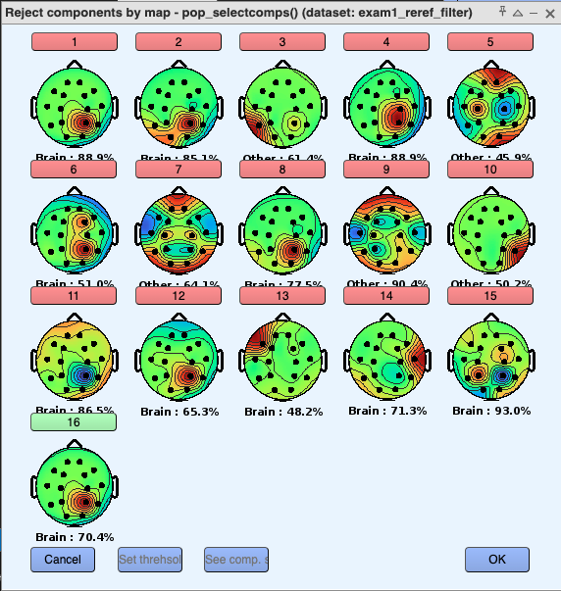

MARA rejected almost all the electrodes. But it was rejected based on the following criteria.

* A high FitError and a high 8-13Hz feature indicate that the component contains an ↵ peak and thus neuronal activity. A high value indicates a spectrum with high values in the 20-50 Hz range, which is a sign that the component contains muscle activity. A high Local Skewness value indicates outliers in the component’s time series. A high Range in Pattern and Current Density Norm indicates a scalp map that is unusual for a neuronal component.

So by tweaking the criteria based on our need, we can automate the preprocessing process.